January 9, 2026

N O T I C E
By Order of Chair David J. Weinstein, acting in accordance with Chapter I, Section 3 of the Rules of the School Committee, there will be a hybrid Special Meeting of the School Committee on Wednesday, January 14 at 4:00 p.m. held in and broadcast from the Dr. Henrietta S. Attles Meeting Room, Cambridge Rindge, and Latin School, 459 Broadway, Cambridge to entertain a motion to convene in executive session for the purpose of discussing strategy for collective bargaining (CEA Units A&B, C, D and E) as an open meeting may have a detrimental effect on the bargaining position of the School Committee.
The Special Meeting will be live-streamed at www.cpsd.us and broadcast on Cambridge Educational Access TV (CEATV) Channel 26 as usual. The Special Meeting can also be viewed on Zoom at https://zoom.us/j/96081106637.

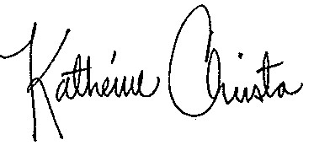

Katherine Christo
Executive Secretary to the Cambridge School Committee

c: School Committee Members
Superintendent
Administration
City Clerk
Principals
Family Liaisons
Student Representatives, CRLS

Note: No votes will be taken and the Committee will not reconvene in open session. There will be no public comment.

Posted at the City Clerk’s Office 1/9/26 11:43 a.m.

